Title: Incremental Construction of Minimal Acyclic Sequential Transducers from Unsorted Data
Link: https://arxiv.org/abs/cs/0408026
1)What is expects as input:
w(1) → o(1)
w(2) → o(2) w(i)=input word
... o(i)=output word
w(m) → o(m)
example:
study → study
studying → study+ing
studied → study+ed
happy → happy
happiness → happy+ness

2. How the input data is processed:
The processing happens in 3 stages:
Step 1 — Build an initial prefix structure:
The words are inserted ine by one like tree
Example dictionary: study, studying, studied
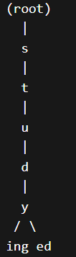 so, the prefix which are common are stored once
Step 2 — Convert prefix structure to a sequential transducer:
Each edge stores input symbol / output symbol
Example transition:
y / y
i / +ing
e / +ed
Example path:
s → t → u → d → y → i → n → g
Example:
study + ing
Step 3 — Incremental minimization:
Instead of :
build automaton
then minimize
the algorithm does:
insert word
minimize immediately
So after inserting each word:
T1 → T2 → T3 → ... → Tm
Where each transducer is already minimal.
Equivalent states are merged using right-language equivalence.
Two states are equivalent if they accept the same suffix strings.
Example:
reading
writing
Both share suffix:
ing
So those states are merged.

Output:
q0 --s--> q1
q1 --t--> q2
q2 --u--> q3
q3 --d--> q4
q4 --y--> q5
q5 --i--> q6
q6 --n--> q7
q7 --g--> q8
output:
q4 → output "study"
q7 → output "+ing"

final workflow:
Dictionary (input-output word pairs)
↓
Incremental insertion of words
↓
Prefix sharing structure (Trie-like)
↓
Sequential Transducer creation
↓
Incremental minimization (state merging)
↓
Minimal Acyclic Sequential Transducer
↓
Word lookup by traversal
↓
Output = root + suffix

Paper Title: H M M - B a s e d Word Alignment in Statistical Translation
Link: https://aclanthology.org/C96-2141.pdf
What it expects as input: It excepts a dictionary. Each word is treated as sequence of alphabets. Input format is like this Dictionary = {w1, w2, w3, ... wn}, w1 = happy,w2=happiness ,w3 = happily
How the input data is processed:
Step 1 — Prefix analysis:
Suppose if we take the words for example are above the prefix is happ and stories it.
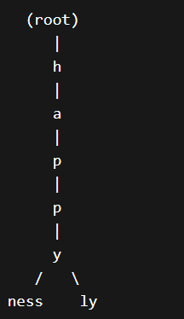
Explanation:
- Each node = a state
- Each edge = a character transition
- Words that share prefixes share the same path.
Step 3 — Convert Trie into Finite State Automaton (FSA):
q0 --h--> q1
q1 --a--> q2
q2 --p--> q3
q3 --p--> q4
q4 --y--> q5
q5 --n--> q6
q6 --e--> q7
q7 --s--> q8
q8 --s--> q9
final are q5 and q9
Step 4 — Automaton minimization:
Many suffix structures are identical.
Example:
reading
writing
Suffix:
ing
The automaton merges identical suffix paths.
So instead of storing "ing" multiple times, the automaton stores it once.
This creates a Minimal Deterministic Finite Automaton (DFA).
Benefits:
- smaller memory
- faster lookup
- efficient lexical representation

